Pursue your passion
Business
Academy
CA$H
in Business

♦ Lompoc High School ♦ 515 West College Avenue ♦ Lompoc, CA 93436 ♦ 805-742-2983 ♦ www.lhscash.org ♦
MICROLOAN PROJECT
Students in the Virtual Business course are participating in a Microloan Project as part of the curriculum. The purpose of this project is to engage the students by practicing the lessons learned in the classroom with the opportunity for personal profit.
The students have selected items that they believe can be sold for a profit. A market survey was completed to determine if there is an interest in their products and to determine the optimal pricing for their products in order to maximize profits. The students researched vendors and the cost of the products and have placed an order for up to $25 worth of products which they will sell at a profit.
The students will have three weeks to sell their products. At that time the students must repay the microloan - amount of original purchase (not to exceed $25). The students will keep any profit they have earned.
If a student is unable to sell the product, they will be required to participate in a fundraiser to payback any remaining balance of the microloan.

Name of student ______________________________________ Date _______________
Product(s) to be sold______________________________ Approximate cost __________
I give permission for my student to participate in the microloan project. I understand that the total amount of the loan (not to exceed $25) must be repaid from the sale of the products or through school fundraisers.
__________________________________ __________________________________
^{Print Parent/Guardian Name} ^{Parent Guardian Signature}
Date ____________________ __________________________________
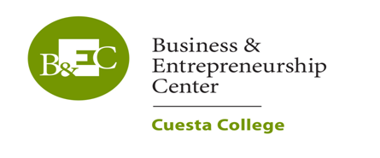
^{Student Signature}
